IFOX-00503274

BCBS MA noticed the wording below looks confusing and is referencing a prior date (4/30). Is this Date something that can be fixed? The member opted out in January (1/22), but went through the two months of Dunning and is now precluded.  
  
Also, similar to my prior question, will that balance update as more billing posts (for example, after the 5/3 invoice tomorrow)?  
  
805000000090 ? HCF0805  
  
Current Severity: 3-Medium

Action – we would not be showing the delinquency msg after the minimum Payment Due Date is passed

Scenario 1 – when the member is voluntarily termed

Test case 1 . when the minimumPaymentDueBy (grace date ) is in past

Then since the date is ended we would not be showing the delinquency banner message

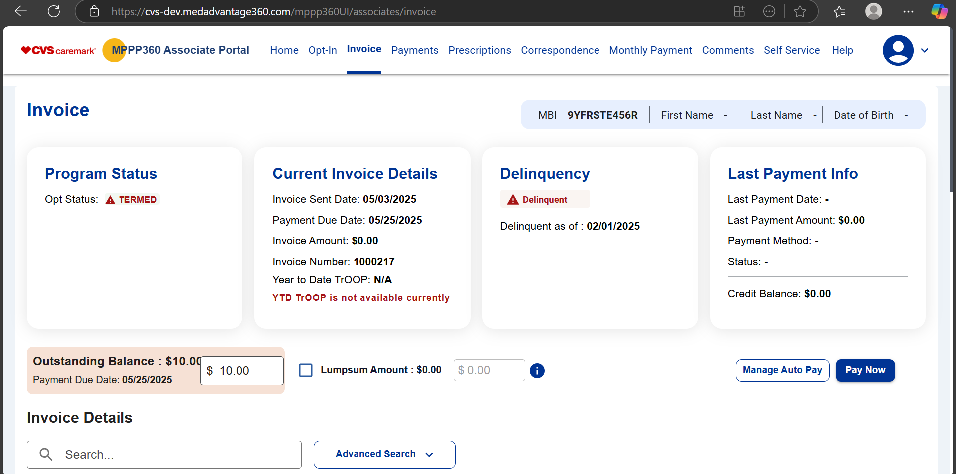

Result – the delinquency banner wont be there

Test case 2 : when the minimumPaymentDueBy (grace date ) is in future

Then will show that message as the we still have a window to pay the due

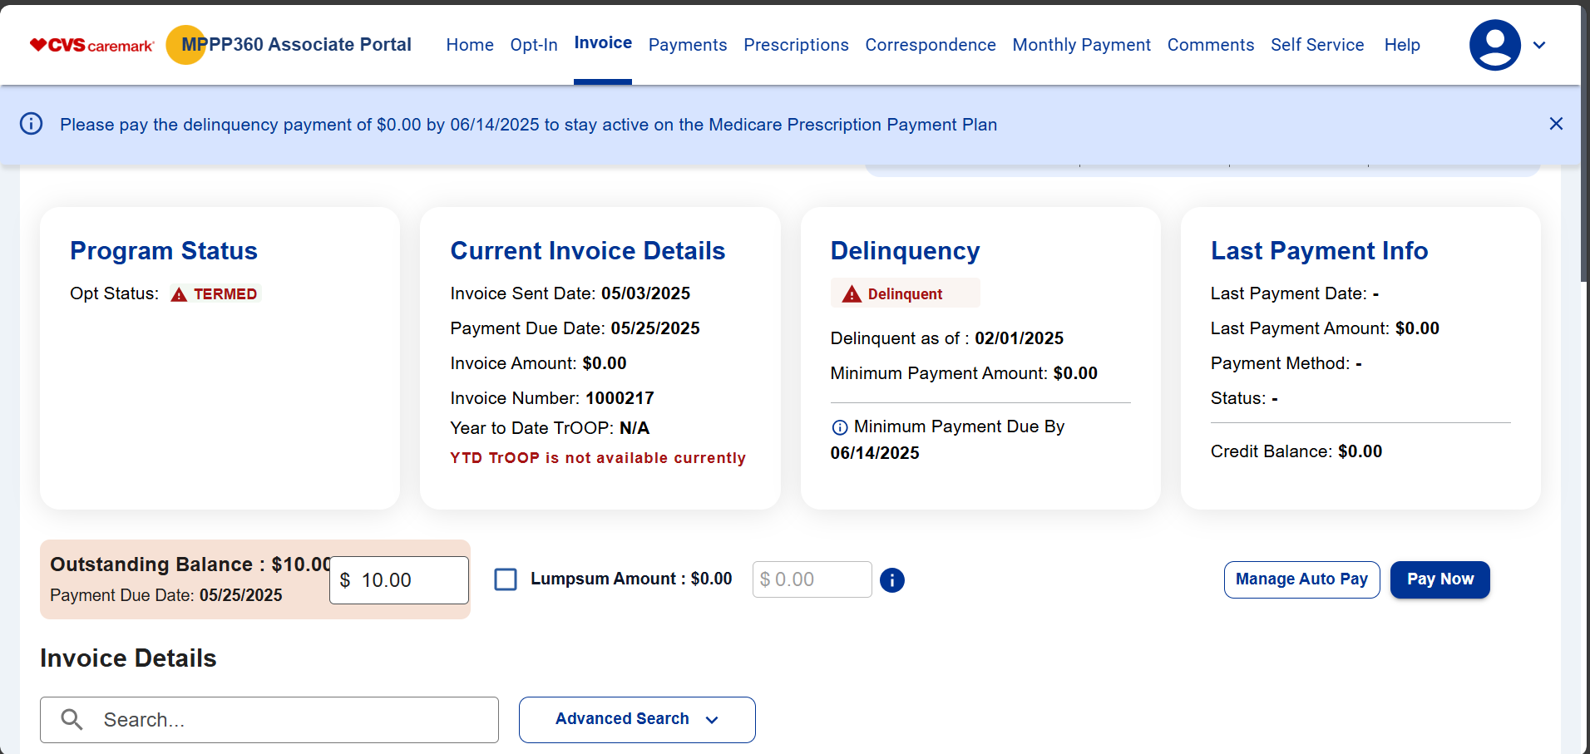

Result – since the delinquency date is there show will show the banner message

Test case 3. When the date is equal to current date

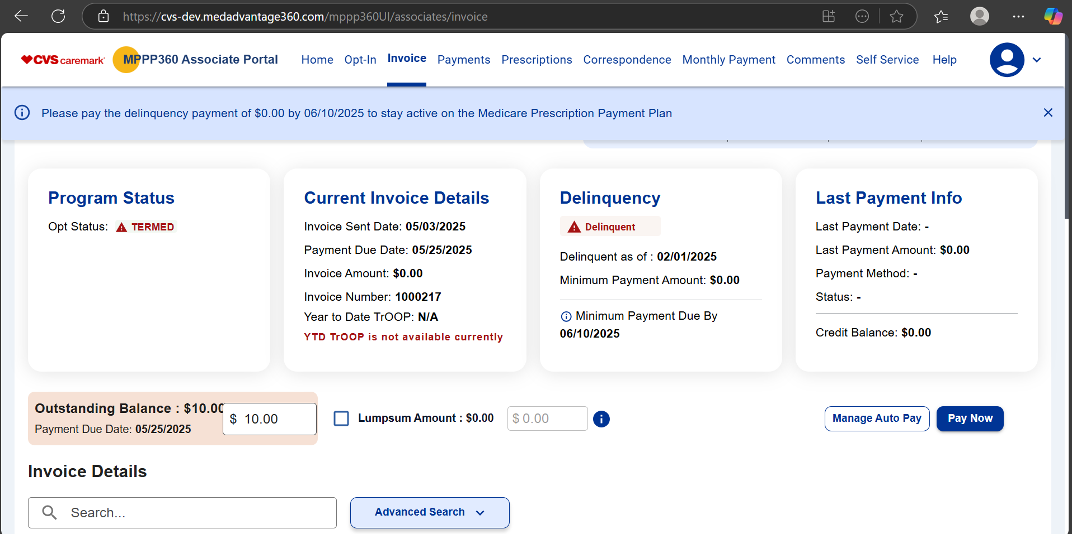

Scenario 2 :

Test case – when its involuntarily optout , in that case the banner should not be displayed

